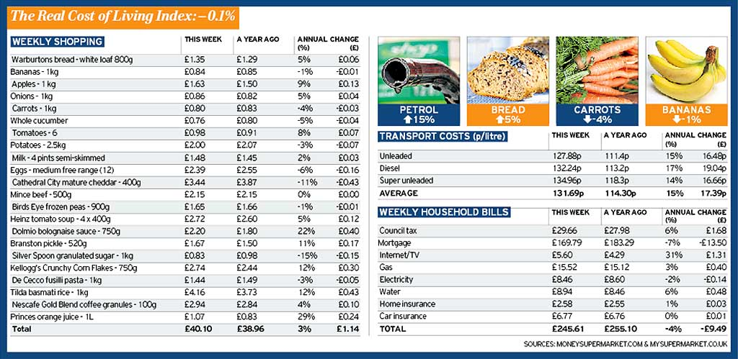

- Shade the items that have risen in price in one color & the items that have fallen in price in another.
- Try to identify which products you think are domestically produced & which ones are imported – label with an I or D.
- Work out the difference in the price changes for the imports & domestic products.
- Write a paragraph trying to explain the causes of this change in the cost of living.

